Volume light

📘 Definition
# Source: AI Source: Provided by: [Data Path: Persons Table -> ID Column: 1, Name_En Column: Motasem Essam] -> From: [ChatGPT] on [5/2/2026]
Volume light (also called volumetric light) is light that becomes visible as it passes through a medium like fog, dust, smoke, or air, creating visible light beams in a 3D space.
Instead of just lighting objects, it lights the space itself.

🌫️ How volume light works
# Source: AI Source: Provided by: [Data Path: Persons Table -> ID Column: 1, Name_En Column: Motasem Essam] -> From: [ChatGPT] on [5/2/2026]
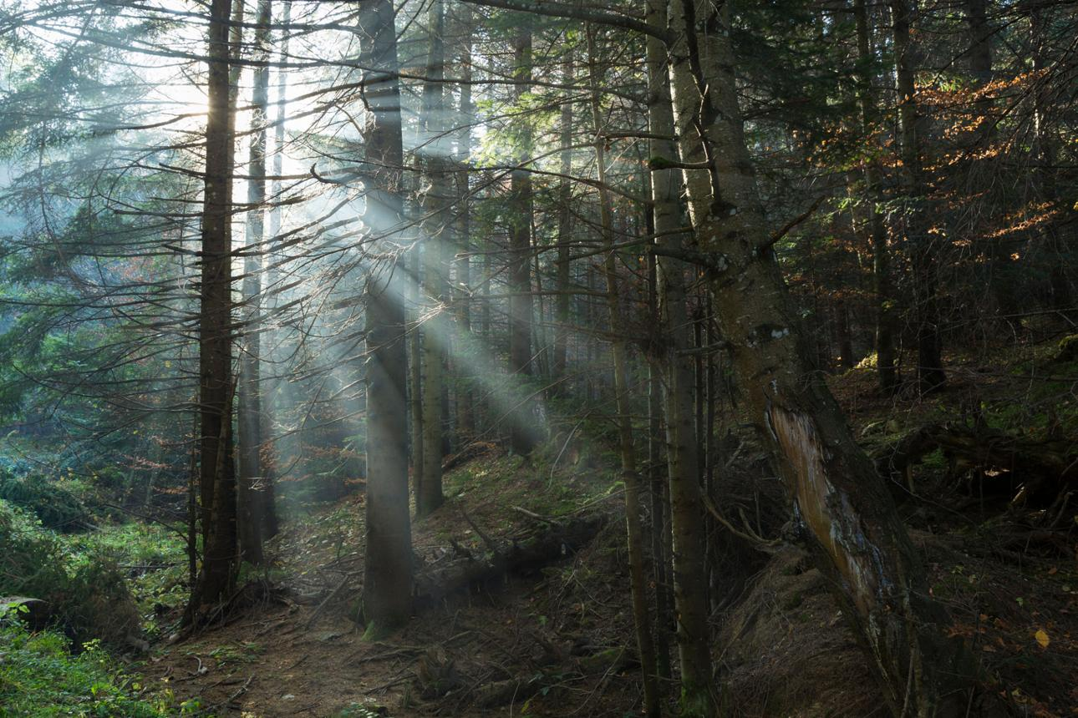
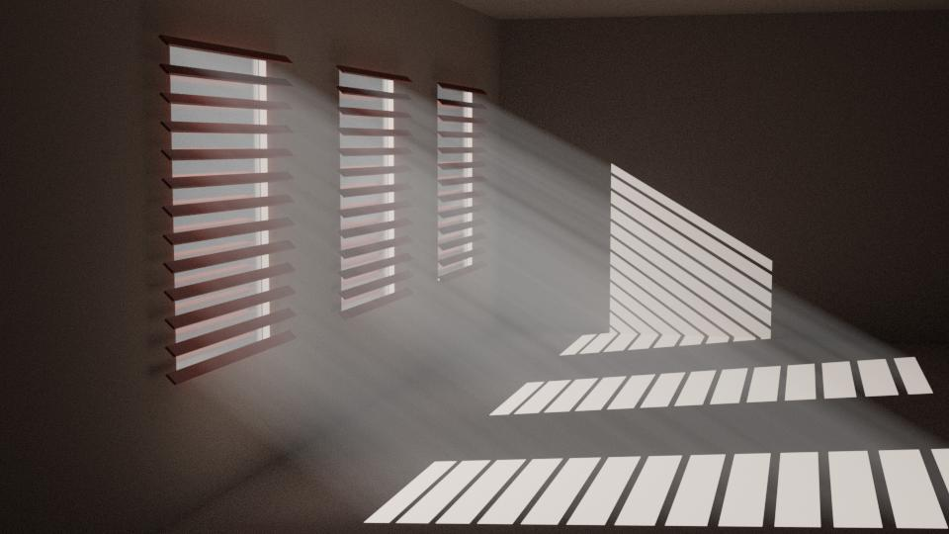
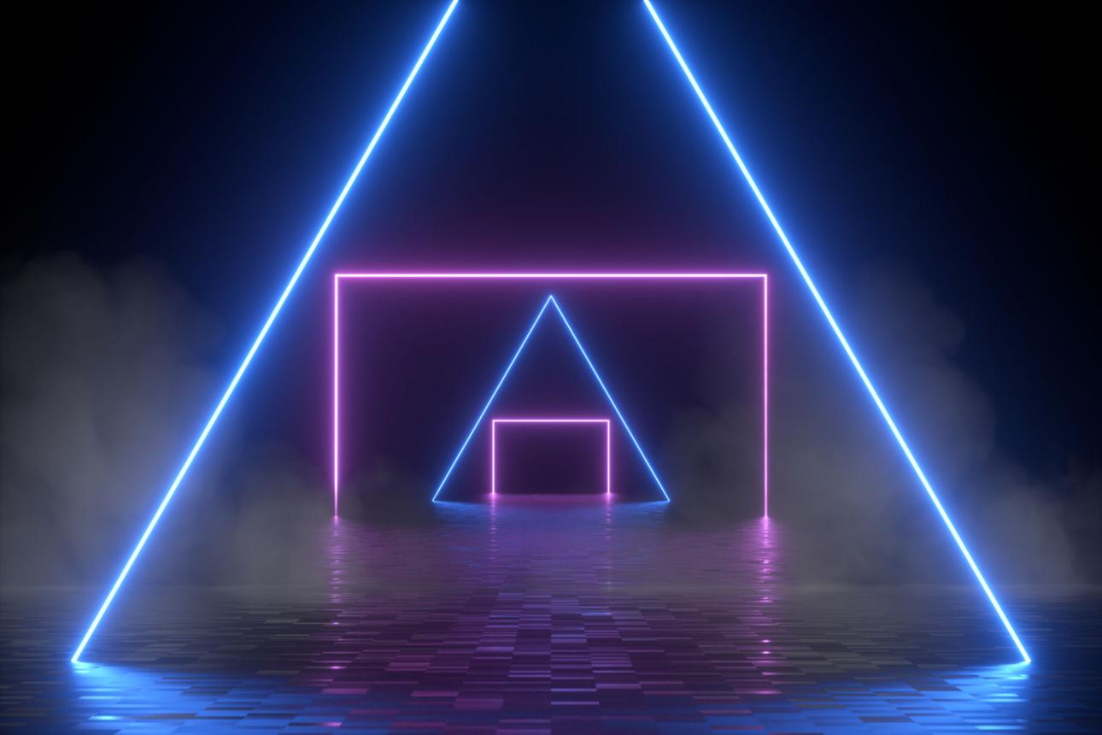
- Light travels through particles in the air
- Particles scatter the light
- This makes the light visible as beams or rays
- Stronger in foggy or dusty environments

🧠 Simple example
# Source: AI Source: Provided by: [Data Path: Persons Table -> ID Column: 1, Name_En Column: Motasem Essam] -> From: [ChatGPT] on [5/2/2026]
Think of:
- ☀️ Sunlight through a forest → visible light rays
- 🪟 Sunlight through a dusty room window
- 🎭 Stage lights in a smoky concert hall
You can actually “see” the light path in the air.

🎮 Volume light in computer graphics
# Source: AI Source: Provided by: [Data Path: Persons Table -> ID Column: 1, Name_En Column: Motasem Essam] -> From: [ChatGPT] on [5/2/2026]
Volume light is used to:
- Create realistic fog and atmosphere
- Add dramatic lighting effects (god rays)
- Improve immersion in games and movies
- Simulate air, smoke, or dust effects

⚙️ Key features
# Source: AI Source: Provided by: [Data Path: Persons Table -> ID Column: 1, Name_En Column: Motasem Essam] -> From: [ChatGPT] on [5/2/2026]
- 🌫️ Light is visible in the air, not just on objects
- 🌈 Depends on particles like fog or dust
- 🎬 Creates dramatic and cinematic effects
- 💡 Adds depth and realism to scenes

🚀 In short:
# Source: AI Source: Provided by: [Data Path: Persons Table -> ID Column: 1, Name_En Column: Motasem Essam] -> From: [ChatGPT] on [5/2/2026]
Volume Light = light that becomes visible as rays when it passes through fog, dust, or smoke in a 3D scene.

